TCOE COMPASS Project
Program Excellence Rubric

Item | 0 Point |  | ¼ Point |  | ½ Point |  | ¾ Point | Full Point
Accreditation | Program is not industry accredited (Above HLC accreditation) |  |  |  | Actively engaged in becoming Industry accredited. |  |  | Program is industry accredited (ASE, AED, etc.) or meets Federal Regulations on education (FAA, ELDT, etc.)
Industry Partnerships  (not mentioned elsewhere in rubric) | No documented industry partner activities in the last year |  | At least 1 industry partner activity in the last year |  | At least 2 industry partner activities in the last year |  | At least 3 industry partner activities in the last year | At least 4 industry partner activities in the last year
Diversity Emphasis  (based on US Census data for county in which program/ college is located) | This section will be scored based on college enrollment and completion rates based on gender and racial demographics compared to the US Census “QuickFacts” data points for the county in which the program/college resides. 5 boxes for each demographic will show if each demographic varies by 5%, 10%, 15%, 20%, or >20% of US Census data. Categories will be averaged for final score within rubric.
 | Category Averages vary by >20% | Category Averages vary by 15%-20% |  | Category Averages vary by 10%-15% |  | Category Averages vary by 5%-10% |  | Category Averages vary by 0%-5%
Work-Based Learning | Apprenticeship/internship program is not required |  | Has required apprenticeship/internship program |  | Has required apprenticeship/internship program, AND a yearly, program specific, High School Career Exploration/Outreach Event |  | Has required apprenticeship/internship program, AND at least 2 yearly, program specific, High School Career Exploration/Outreach Events | Has required apprenticeship/internship program, at least 2 yearly, program specific, High School Career Exploration/Outreach Events, AND a Job Shadowing option for any interested prospective students.
Advisory Committees | No yearly Advisory Committee meetings during the year |  | Two documented Advisory Committee meetings during the year |  | Two documented Advisory Committee meetings during the year chaired by Industry |  | Two documented Advisory Committee meetings during the year generally following a model of best practice | At least two documented Advisory Committee meetings during the year strictly aligned either by all accreditation requirements or all aspects of a best practice model.
Professional Development  (Technical and Education Development) | No pedagogy or industry technology training attendance on new technology (last 5 years) above/beyond industry accreditation requirements for at least one instructor in program in the last 3 years. |  | Alternating pedagogy or industry technology training attendance on new technology (last 5 years) above/beyond industry accreditation requirements for at least one instructor in program. |  | Yearly pedagogy and industry technology training attendance on new technology (last 5 years) above/beyond industry accreditation requirements for at least one instructor in program. |  | Yearly pedagogy and industry technology training attendance on new technology (last 5 years) above/beyond industry accreditation requirements for at least half of instructors in program. | Yearly pedagogy and industry technology training attendance on new technology (last 5 years) above/beyond industry accreditation requirements for all instructors in program.
Strong HS Partnerships | No yearly class presence OR advisory committee attendance in any area high schools |  | Yearly class presence OR advisory committee attendance in at least 1 area high school |  | Yearly class presence OR advisory committee attendance in at least 2 area high schools |  | Yearly class presence AND advisory committee attendance in at least 2 area high schools | Yearly class presence AND advisory committee attendance in at least 3 area high schools
Modern Equipment | All training equipment is greater than 10 years old |  | Most necessary training equipment is less than 10 years old |  | Utilize new (<5-years old) equipment in at least 1 training session every school year |  | Utilize new (<5-years old) equipment in at least 2 training sessions every school year | Utilize new (<5-years old) equipment in at least 3 training sessions every school year

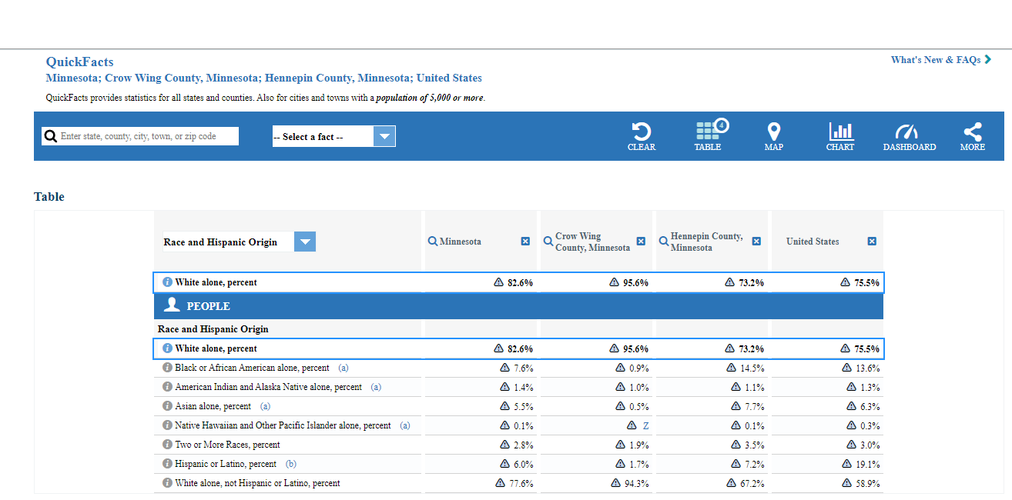
Demographic | Census Data (%) | 3-year Avg. College Enrollment (%) | 25+% | 20% | 15% | 10% | 5%
White alone, percent
Black or African American alone, percent
American Indian and Alaska Native alone, percent
Asian alone, percent
Native Hawaiian and Other Pacific Islander alone, percent
Two or More Races, percent
Hispanic or Latin, percent
White alone, not Hispanic or Latino, percent
Gender – Male
Gender - Female
Demographic | Census Data (%) | 3-year Avg. College Completion (%) | 25+% | 20% | 15% | 10% | 5%
White alone, percent
Black or African American alone, percent
American Indian and Alaska Native alone, percent
Asian alone, percent
Native Hawaiian and Other Pacific Islander alone, percent
Two or More Races, percent
Hispanic or Latin, percent
White alone, not Hispanic or Latino, percent
Gender – Male
Gender - Female

Procedure:
- Identify School to contact.
  - Instructor complaints.
  - Administrative complaints.
  - Known problems.
  - Likelihood of success
- Contact school.
  - Explain COMPASS.
  - Set up an initial meeting.
- Meet with school.
  - Meet with instructors.
    - Listen to/identify issues.
    - Record successes.
  - Meet with administrator(s).
    - Listen to/identify issues.
    - Record successes.
  - Have school stakeholders assess the program.
    - Use program inventory assessment OR,
    - Rate themselves based on rubric.
    - Ensure TCOE staff take assessment and score based on both administrator and instructor feedback from previous meetings.
  - Meet with both administrators and instructors.
    - Identify issues.
    - Accentuate positives.
    - Prioritize issues.
    - Establish goals for improvement of highest priority issues.
    - Determine steps needed to reach goals.
    - Assign duties to complete steps.
    - Determine timeline(s) for completion of steps/goals.
  - Conduct Follow-ups.
    - Should be regular.
    - Can be formal or informal; in-person or virtual.
      - Discuss progress.
      - Identify barriers to success.
      - Develop plan(s) to eliminate barriers to success.
      - Repeat as needed.
    - Should be formal and in-person at least once a year.
      - Official assessment of progress.
      - Identify barriers to success.
      - Develop plan(s) to eliminate barriers to success.
      - Determine next steps.
      - Reassess issues from previous formal, in-person meetings.
        - Prioritize additional issues to address/tackle.
        - Establish goals for improvement of highest priority issues.
        - Determine steps needed to reach goals.
        - Assign duties to complete steps.
        - Determine timeline(s) for completion of steps/goals.
  - Repeat as necessary to achieve/maintain excellence.

