

EV RECOMMENDED TOOLS AND SAFETY EQUIPMENT
Safety Equipment
Image | Item | Link  *Preferred | Cost
 | Class 0, Insulated rubber gloves kit  -Rubber gloves, and protective leather gloves in a storage bag  -Rubber gloves lifespan 6 months  -Different sizes: Size 8-10 covers most people | Grainger  Amazon  AESWave*  How to size gloves | $150-300 Per Set
 | Cotton under gloves (optional) | Grainger*  Amazon | $1-6 Per Pair
 | Glove Dust  (optional) | Grainger* | $15
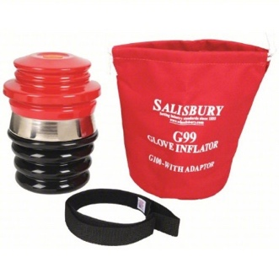 | Rubber Glove Tester  -Used to field test gloves before use | Grainger  Amazon* | $350-600
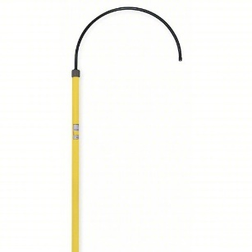 | HV Rescue Hook  (Hot stick)  -Life span: 2 years | Grainger  Amazon  AESWave* | $500-750
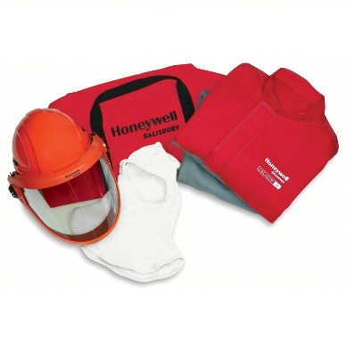 | Arc Flash Clothing Kit  -Some manufacturers require  -Different sizes available  -Category 2  (Might need higher depending on the job being performed)  *See the manufacturer service manual for the recommended level of PPE | Grainger*  Amazon | $700-1000
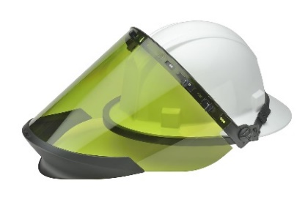 | Arc Flash Face Shield  -Some manufacturers require | Grainger  Amazon* | $72-$470
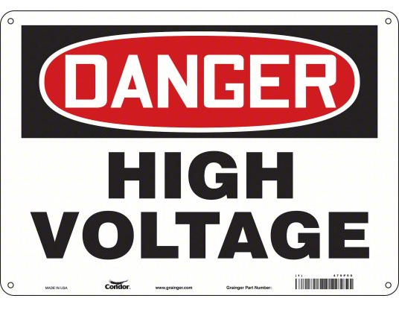 | HV Signage  -You’ll need multiple signs around the vehicle and/or shop | Grainger  Amazon* | $12-25 each
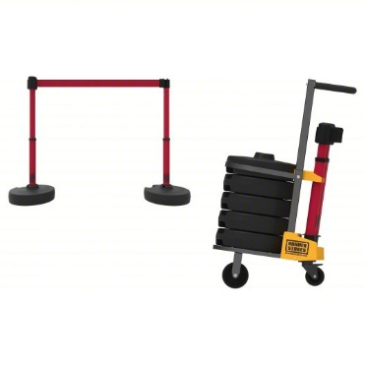 | HV Barrier  -Alternative barriers are possible with tall construction cones with caution tape between them | Grainger*  Alternative:  Grainger 4x Cone  Grainger Caution tape | $1300-1500  $35 each  $65
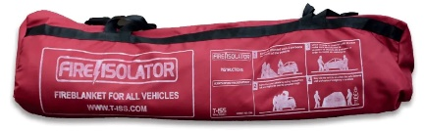 | Large NFPA 701 Certified Fire Blanket  (9M X 6M) | Vehicle Response Training (VRT)  Use code:  Educator250  For a $250 discount | $2,800
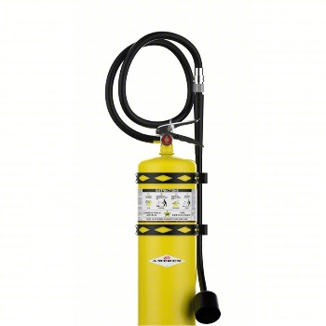 | Class D Fire Extinguisher – Combustible Metals  -Designed to extinguish nickel metal hydride batteries  NOT effective on lithium chemistry batteries | Grainger  ULINE | $900-1,100
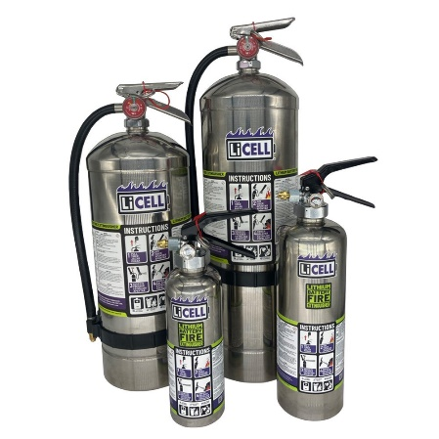 | Lithium Battery Encapsulator Fire Extinguisher  -Designed to combat lithium battery fires.  Only use if the fire is small and containable.  Place fire blank over component/vehicle ASAP. | All Hands Public Safety | $300-900
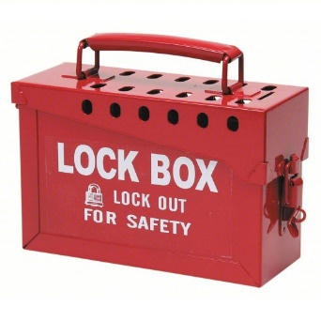 | Lock Box  -Lock vehicle key and MSD away when HV system is being serviced | Grainger  Amazon* | $32-70
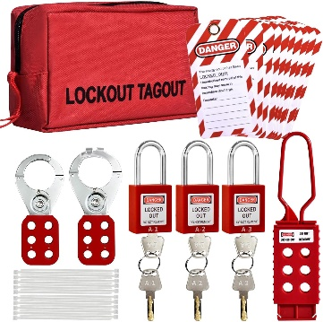 | Lock Out, Tag Out Kit | Grainger  Amazon* | $33-182

Basic EV Tools and Equipment
Image | Item | Link  *Preferred | Cost
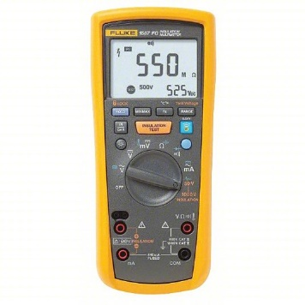 | CATIII Multi Meter with insulation tester – Fluke 1587 | Grainger  Amazon*  AESWave | $750-1100
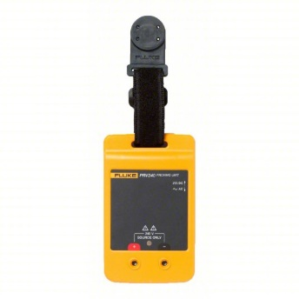 | Proving unit FlukePRV240  -Alternative 9-volt battery | Grainger  Amazon* | $160-170
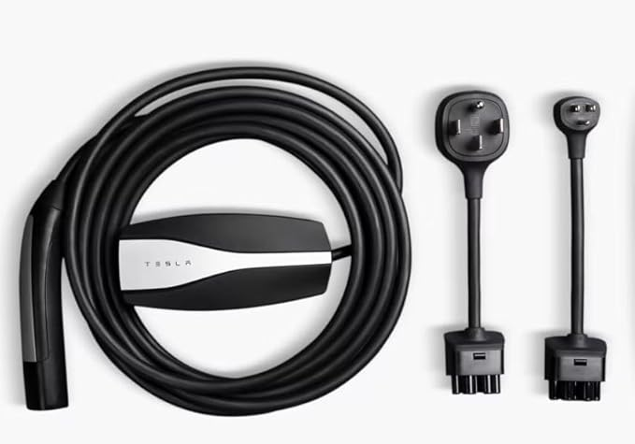 | Level 1 & 2 NACS(Tesla) Charger | Amazon* | $300
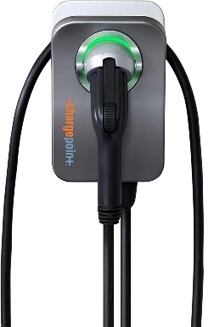 | Level 2 J1772 Charger  -You’ll need an electrician to add a 240 Volt plug/hardwire charging unit | Amazon*  NorthernTool | $550-600
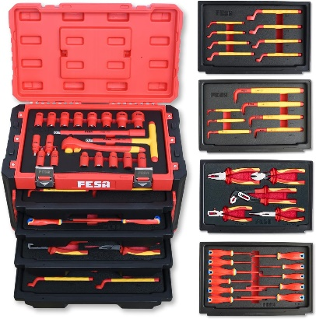 | Insulated Tool Kit | Grainger  Amazon*  NorthernTool | $530-2010
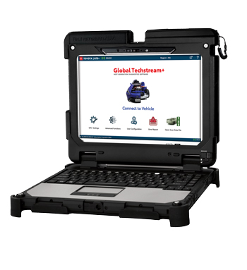 | OEM Factory Scan Tool  -Recommend OEM factory scan tool for the EV you plan on working on the most.  Example: Toyota TIS TechStream. | Toyota-TechStream | $6,330

Advanced EV Tools and Equipment
Image | Item | Link  *Preferred | Cost
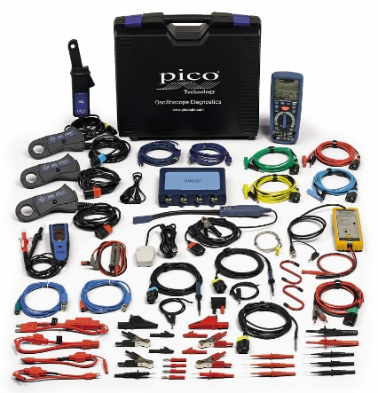 | 4-Channel Pico EV Kit 4425A  -This is a great kit that has most of the things to scope HV components safely | AESWave* | $5,650
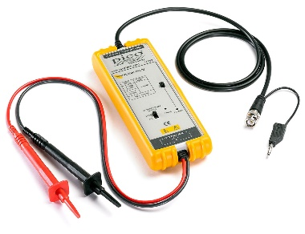 | Additional Differential Probes  (optional)  -Ideally 3 total | Amazon  AESWave* | $460
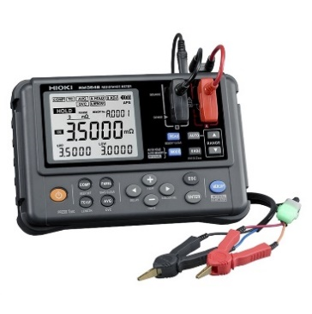 | Milliohm Meter  -Used to measure electrical resistance in motor windings | Amazon- Hioki  ASEWave*- Hioki  AESWave-PICO  Milliohm Meter Explained | $1,100-1,400  $860

Other things to think about…
Image | Item | Link
 | Faraday Bag  Adding a designated location for the key fob helps prevent the vehicle from unintentionally powering on when the key is within range. | Amazon*-  Two Bag Set for $15
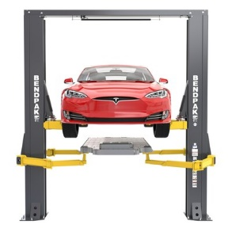 | HD Hoist (Wider) or Special EV hoist  (optional)  -Wider hoist to accommodate lowering HV Batteries | FleetMaintenance- Hoist Evolving  BendPak- EV hoist Concept  Rotary Hoist- EV lift new arms
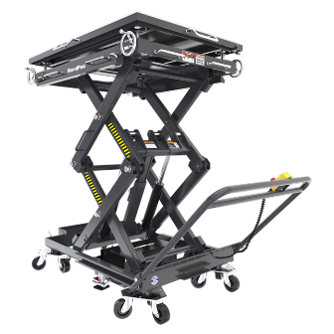 | EV Battery Lift Table and Fixtures  -2,400-4,500LBS rated depending on what vehicles you have  -Some tables will need additional fixtures to drop some batteries | BendPak- EV battery lift tables  Hyundai-EV battery lift tables  Challenger- Lift tables
 | Insulated Workbenches and Storage Shelves  -Wood or nonconductive material to work on and store HV Batteries | Global Industrial- Wood workbench  Global Industrial- ESD Tabletop
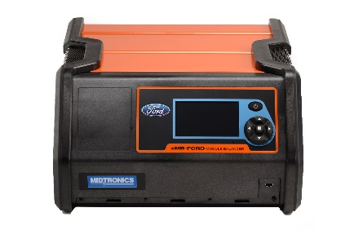 | High-Voltage Module Balancer (optional)  -If you plan on doing high-voltage battery internal servicing of modules, you’ll need the manufactured recommended balancer, Example: Ford’s recommended balancer from Medtronic  -*Not all manufacturers are servicing HV battery packs | FORD Rotunda  Midtronics Site and Video

